1.What are the two values of the Boolean data type? How do you write them?

The two values of the Boolean data type are True and False, first letter of both True and False is in uppercase. It is used to represent logical values in program. It can be used in conditional statements and loops statements to determine the flow of a program based on whether a certain condition is True or False.

2. What are the three different types of Boolean operators?

AND : It is denoted by the symbol and, it returns True if both the operands are True, otherwise it returns False.

OR : It is denoted by the symbol or, it returns True if either of the operands are True, otherwise it returns False.

NOT : It is denoted by the symbol not, it returns the opposite of the Boolean value of the operand. If the operand is True, it returns False, and if the operand is False, it returns True.

3. Make a list of each Boolean operator's truth tables (i.e. every possible combination of Boolean values for the operator and what it evaluate ).

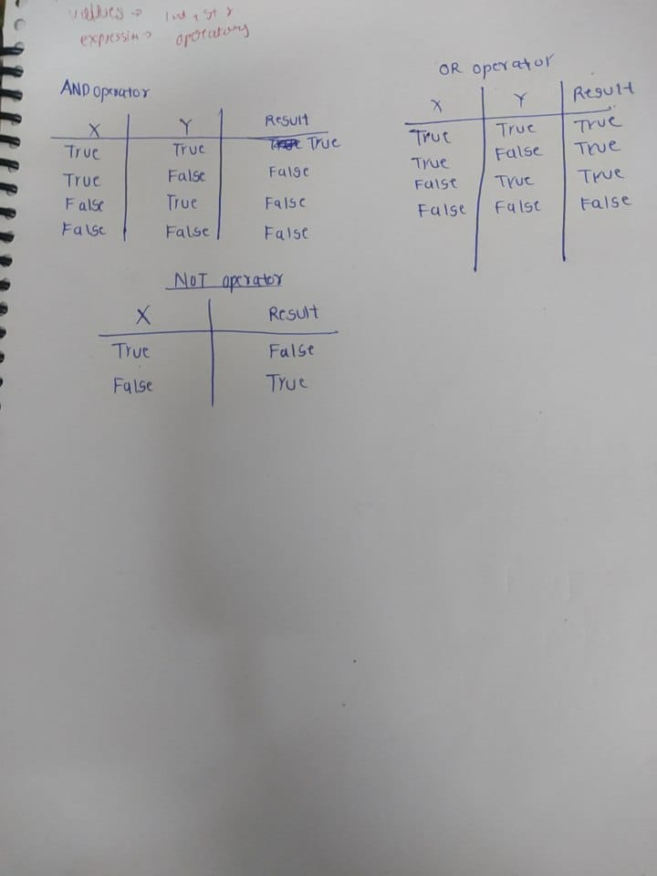

4. What are the values of the following expressions?

(5 > 4) and (3 == 5) : False

not (5 > 4) : False

(5 > 4) or (3 == 5) : True

not ((5 > 4) or (3 == 5)) : False

(True and True) and (True == False) :False

(not False) or (not True) : True

5. What are the six comparison operators?

1. Equal to (==): It returns True if the two values are equal, and otherwise False.
2. Not equal to (!=): It returns True if the two values are not equal, and otherwise False.
3. Greater than (>): it returns True if the first value is greater than the second value, and False .
4. Less than (<): It returns True if the first value is less than the second value, and otherwise False.
5. Greater than or equal to (>=): It returns True if the first value is greater than or equal to the second value, and otherwise False .
6. Less than or equal to (<=): It returns True if the first value is less than or equal to the second value, and otherwise False.

6. How do you tell the difference between the equal to and assignment operators? Describe a condition and when you would use one.

The equal to operator (==) is used to compare two values , it always returns a Boolean value (True or False) depending on whether the two values are equal or not. , while the assignment operator (=) is used to assign a value to a variable and it doesn’t return anything.

# using equal to operator

x , y = 5 , 6

if x == y:

print("x is equal to y")

else:

print("x is not equal to y")

# using assignment operator

x = 5

print("The value of x is:", x)

7. Identify the three blocks in this code:

spam = 0 # Block 1 start here

if spam == 10:

print('eggs') # Block 1 End here

if spam > 5: # Block 2 Start here

print('bacon') # Block 2 End here

else: # Block 3 Start here

print('ham')

print('spam')

print('spam') # Block 3 End here

8. Write code that prints Hello if 1 is stored in spam, prints Howdy if 2 is stored in spam, and prints Greetings! if anything else is stored in spam.

if spam == 1:

  print("Hello")

elif spam ==2:

  print("Howdy")

else:

  print("Greetings!")

9.If your programme is stuck in an endless loop, what keys you’ll press?

Ctrl + C

10. How can you tell the difference between break and continue?

Break is used to exit out of a loop completely, while continue is used to skip the current iteration and move on to the next iteration of the loop.

If we have to print numbers from 1 to 5 but exclude the number 3, we can use the continue statement to skip the iteration that prints the number 3.

i = 0

while i < 5:

    i = i+1

    if i == 3:

        continue

    print(i)

Now if we use break instead of continue in same above code , the loop would terminate when i is equal to 3, and only the numbers 1 and 2 would be printed in the console.

i = 0

while i < 5:

    i = i+1

    if i == 3:

        break

    print(i)

11. In a for loop, what is the difference between range(10), range(0, 10), and range(0, 10, 1)?

1. range(10): This creates a sequence of numbers from 0 to 9 (9 is included) . Here jump is taken default 1.
2. range(0,10): This creates a sequence of numbers from 0 to 9 (9 is included). Here jump is taken default 1.
3. range(0,10,1): This creates a sequence of numbers from 0 to 9 (9 is included). Here jump is given which is 1.

12. Write a short program that prints the numbers 1 to 10 using a for loop. Then write an equivalent program that prints the numbers 1 to 10 using a while loop.

# using for loop

for i in range(1,11):

  print(i)

.

#using While loop

i=0

while i<10:

  i=i+1

  print(i)

13. If you had a function named bacon() inside a module named spam, how would you call it after importing spam?

import spam

spam.bacon()